**Title: Adapting the HEAT Physical Activity module to incorporate a non-linear physical activity dose response function.**

Authors: Smith, RA. Thomas, C., Goyder, E. (potentially: Hafner, M., Kahlmeier, S., Gotski, T.)

Keywords: Physical Activity, Dose Response Function, HEAT, Economic Analysis

Target Journals: Journal of Physical Activity and Health, Journal of Transport and Health, Transport Policy, Environmental Health Perspectives, World Health Organization Europe, Regional Office for Europe

-----------------------------------------------------------------------------------------------------------------------------------

**Thumbnail Sketch**

**What is already known on this subject?**

One of the models most widely used to estimate the health benefits of changing population physical activity levels is the Health Economic Assessment Tool for cycling and walking. The tool’s physical activity module assumes a linear dose response relationship between physical activity and mortality. It does this in part because estimating benefits using a non-linear relationship requires a baseline distribution, which is not available for many countries.

**What this study adds?**

This study estimates the population physical activity distributions for 49 HEAT countries. It then compares, for three different scenarios, the results generated by the current method, using a linear dose response relationship with results generated by a new method using a non-linear dose response relationship. The study finds that estimated deaths averted are relatively higher (lower) using the non-linear effect in countries with less (more) active populations. Since more active populations, e.g. in Eastern Europe, also tend to have lower Value of a Statistical Life estimates the net monetary benefit estimated by the scenarios are much higher in western-Europe than eastern-Europe.

**Implications**

While the use of a linear effect simplifies the mathematical model used to estimate the benefits of physical activity, it may not be appropriate where populations are particularly inactive, as is the case in many of the western-European countries, or particularly active, such as the eastern-European countries. Estimating a baseline distribution is possible with limited additional data requirements, although the method has yet to be validated.

-----------------------------------------------------------------------------------------------------------------------------------

**Abstract**

**Background**

The WHO-Europe’s Health Economic Assessment Tool is a tool used to estimate the costs and benefits of changes in walking and cycling. Due to data limitations the tool assumes a linear dose response relationship between physical activity and mortality.

**Methods**

This study estimates baseline population physical activity distributions for 44 countries included in the HEAT. It then compares, for three different scenarios, the results generated by the current method, using a linear dose response relationship, with results generated by a new method, using a non-linear dose response relationship.

**Results**

The study finds that estimated deaths averted are relatively higher (lower) using the non-linear effect in countries with less (more) active populations. Since more active populations, e.g. in Eastern Europe, also tend to have lower Value of a Statistical Life estimates the net monetary benefit estimated by the scenarios are much higher in western-Europe than eastern-Europe.

**Conclusions**

Using a non-linear dose response function results in much different estimates where populations are particularly inactive, as is the case in many of the western-European countries, or particularly active, such as the eastern-European countries. Estimating a baseline distribution is possible with limited additional data requirements, although the method has yet to be validated.

## Introduction

There is consensus that there exists a non-linear dose response relationship between physical activity and all-cause mortality, such that the greatest health benefits from an extra unit of physical activity accrue in those who are least active (Arem et al., 2015; Kelly et al., 2014). When attempting to estimate the impact of changing the physical activity levels of the population, public health economists would ideally like to incorporate this non-linear relationship. However, often data limitations mean that we do not know the initial distribution of physical activity in a population. In this case it is not possible to utilize a non-linear function and we must instead revert to assuming a linear relationship between physical activity and risk of adverse health events, for example mortality.

The World Health Organization’s Health Economic Assessment Tool for Walking and Cycling (HEAT) is an example of a “Health in All Policies” approach which aims to ensure that health effects are considered within other sectors, for HEAT tool this is largely transport planning (Kahlmeier et al., 2010). The HEAT methods and user guide states that “a linear relationship was chosen to avoid additional data requirements on baseline activity levels (which would be needed using a non-linear dose–response function)” (Kahlmeier et al., 2017; p.30).

This study adapts the HEAT methods to allow for the use of a non-linear dose-response function. It does this by using a method developed by Hafner et al. (2019) to estimate the current distribution of physical activity in countries where detailed physical activity data is not available. It then compares the estimated monetary benefit associated with increases in population physical activity using a non-linear dose response function (Kelly et al., 2014) to the existing linear response function used within the HEAT physical activity module (Kahlmeier et al., 2017).

# Method

## Data and Measures

This study uses data on the prevalence of insufficient physical activity in 49 HEAT countries from a study published by Guthold et al. (2018), the self-reported physical activity levels of a representative sample of the English population (Health Survey for England 2015 (REF)), and country specific mortality and value of a statistical life estimates (HEAT team). It uses the dose response relationship between physical activity and mortality for walking and cycling from Kelly et al. (2014).

Table . Variable names, description and source of data used in analysis

|  |  |  |
| --- | --- | --- |
| Variable | Description | Source |
| Country.PIA | % of population inactive | Guthold et al. (2018), Appendix 5 |
| Generic.PAdist | Distribution of MET-mins | HSE (2015) |
| Country.MR | HEAT 20-74 mortality rate | HEAT team |
| Country.VSL | Value of a Statistical Life | HEAT team |
| Mort.DRF | Dose Response Function PA-Mortality | Kelly et al. (2015) |

## Analysis

In order to compare the new method (non-linear dose response) with the current method currently used by HEAT (linear dose response), we compare, for 49 HEAT countries, the estimated monetary benefit in three scenarios:

1. Scenario 1: An extra 10mins/day of walking for every person.
2. Scenario 2: Every adult in the country meeting WHO guidelines.
3. Scenario 3: A 10% increase in physical activity levels of the entire population.

The current method (Linear response)

The current method used by HEAT estimates the change in relative risk in the base case and intervention case by estimating the number of additional minutes of physical activity and using the function:

EQ1:  **= {max} ( – × ()) & )**

Where for walking is 0.89, is 168mins/wk and is 0.7. such that every additional 10 minutes of weekly walking ( reduces relative risk by 0.65 percentage points, to a limit of 30 percentage points.

Net monetary benefit is then calculated by multiplying the difference in relative risk between intervention and baseline by the base mortality rate of the population ( and the country specific value of a statistical life (:

EQ2:  **= () × ×**

The new method (dose response function)

The new method uses the process described in the appendix to estimate the baseline distribution of population physical activity, with met-mins calculated for each percentile of the population.

**RR =**

Relative risk is the sum of the relative risks estimated by the dose response relationship from Kelly et al. (2015), each constrained to a minimum of 0.7, divided by 100 (to provide a mean RR). The same method is applied to give and . Net monetary benefit is then calculated as in equation 2.

In each of the three scenarios, the number of deaths averted per 100,000 population and net monetary benefit was estimated for 49 HEAT countries using the linear (HEAT) and non-linear (new) methods.

# Results

The estimated distributions of physical activity for each of the HEAT countries are provided in the appendix, along with the deaths averted per 100,000 population and Net Monetary Benefit using each method for the three scenarios in 49 HEAT countries. The results for scenario 1, an additional 10 minutes of walking for every person, are shown below.

**Scenario 1: Additional 10 minutes of walking for each person.**

Figure 1 below shows, for each of the 49 countries, a comparison in the estimated number of deaths averted per 100,000 people using the current method (x-axis) and the non-linear dose response relationship (y-axis). A 45-degree line of equality is plotted to aid comparison. The figure shows that countries where the insufficient physical activity prevalence (IPAP) is high, such as Germany, the UK and Serbia have higher estimated deaths averted using the non-linear dose response compared to the linear (current) dose response. The converse is true for countries with to increased physical activity using the new method relative to countries with higher prevalence of physical activity (e.g. Belarus and Moldova).

Figure . Deaths averted per 100,000 for three scenarios using the non-linear method and the current (linear) method.

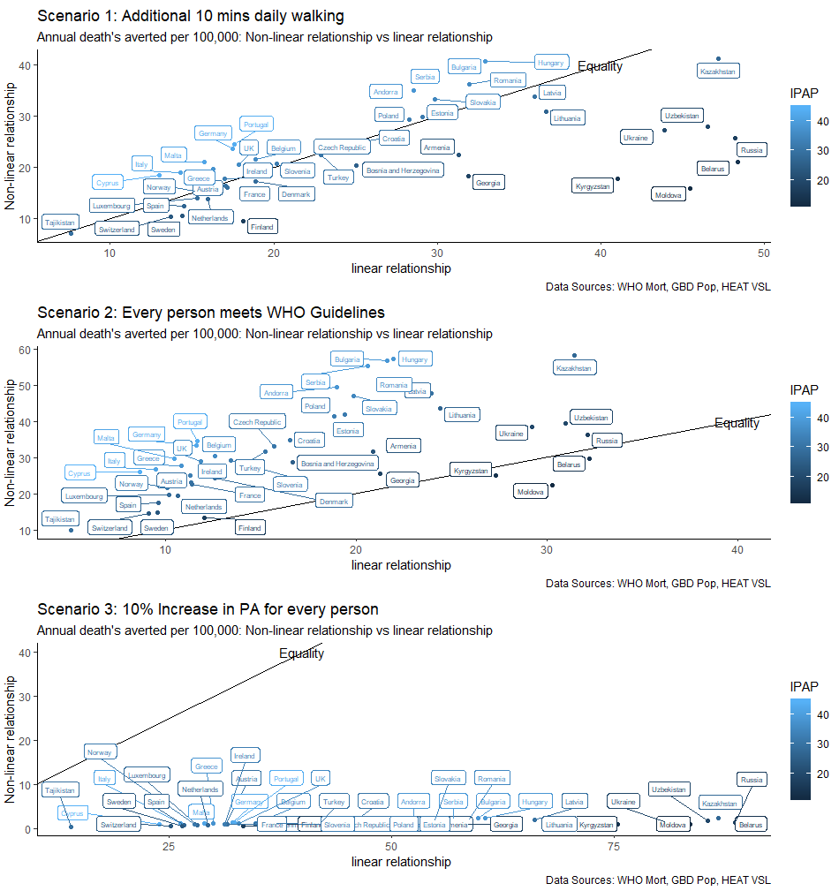

This results in substantially different net monetary benefit results by country. The net monetary benefit values are much larger in western Europe where the VSL is higher and the population is generally less active, relative to eastern Europe where the VSL is lower and the population is more active. 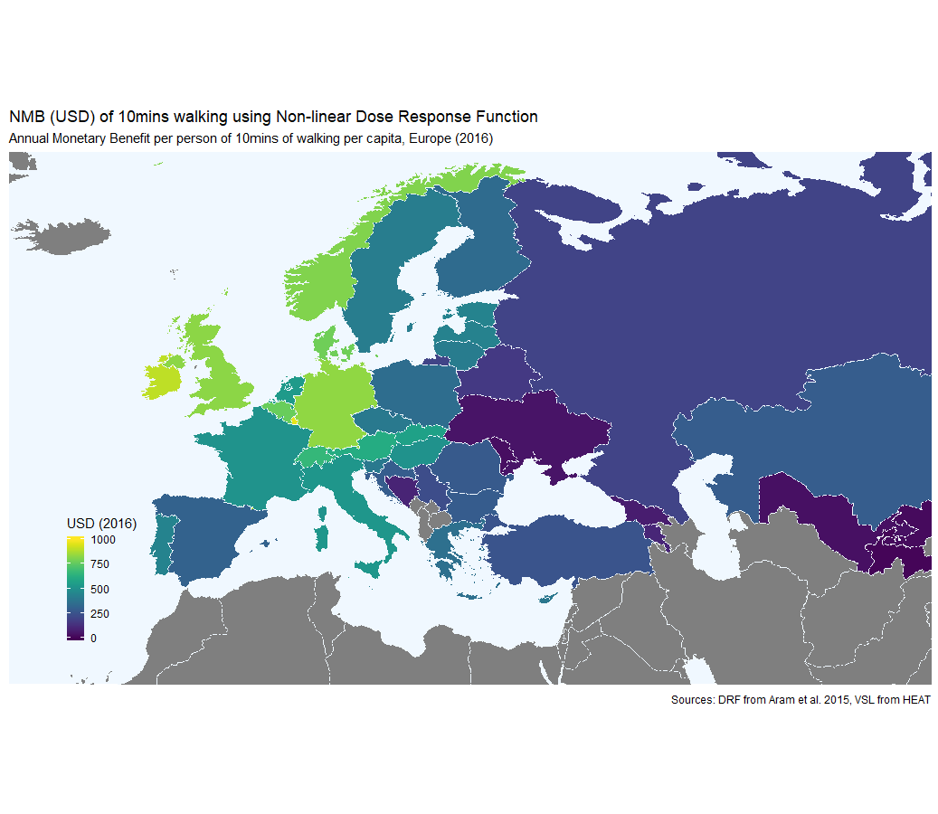

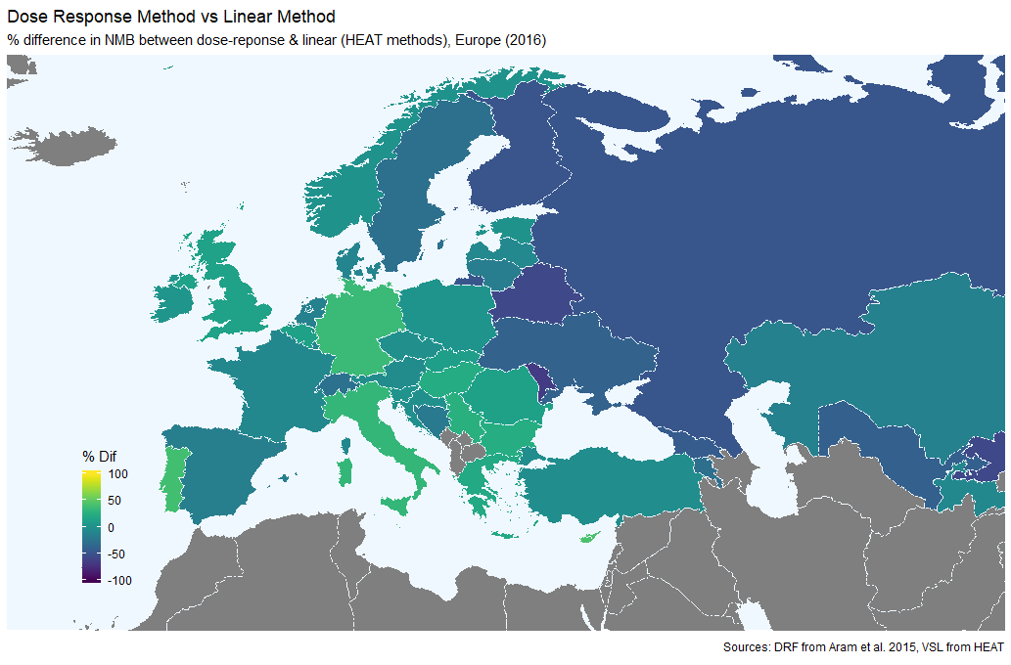

# Discussion

The differences in the two methods highlight the importance for certain types of interventions in incorporating the non-linear dose-response relationship between physical activity and mortality into the calculation. However, the same principles would apply to morbidity, where the dose response function has also been shown to be non-linear.

There are numerous limitations with the method used to estimate the baseline distribution of physical activity for countries without detailed data. Most importantly, the method assumes that the distribution takes a similar form to that of the countries used to create the generic distribution, in this case England. Comparing the distributions estimated by this method with more detailed data-sets from IPAQ surveys for HEAT-Europe countries would provide more clarity as to whether this assumption is reasonable. This seems relatively likely. For developing countries, with very different ways of life, this seems very unlikely.

For the method to be used the user must know what the effect of the intervention is on the distribution of physical activity. Where those effected by the intervention are representative of the population this is relatively simple, but where the intervention population differs in its physical activity levels to the national population the transformation necessary is more complicated.

# Conclusion

The use of a linear dose response relationship has been identified by the HEAT team as necessary limitation given the lack of physical activity distributions for each country. The new method described in this study provides an alternative method which incorporates a non-linear dose response relationship which is likely to more accurately reflect the benefits of physical activity. The change would result in smaller (larger) estimated benefits of interventions which increase physical activity in populations that are already more (less) active.

# References

Arem, H., Moore, S.C., Patel, A., Hartge, P., De Gonzalez, A.B., Visvanathan, K., Campbell, P.T., Freedman, M., Weiderpass, E., Adami, H.O. and Linet, M.S., 2015. Leisure time physical activity and mortality: a detailed pooled analysis of the dose-response relationship. *JAMA internal medicine*, *175*(6), pp.959-967.

Guthold R, Stevens GA, Riley LM, Bull FC. Worldwide trends in insufficient physical activity from 2001 to 2016: a pooled analysis of 358 population-based surveys with 1·9 million participants. Lancet Glob Health 2018

Hafner, M., Yerushalmi, E., Phillips, W.D., Pollard, J., Deshpande, A., Whitmore, M., Millard, F., Subel, S. and Van Stolk, C., 2019. The economic benefits of a more physically active population: An international analysis.

Kahlmeier, S., Racioppi, F., Cavill, N., Rutter, H. and Oja, P., 2010. “Health in all policies” in practice: guidance and tools to quantifying the health effects of cycling and walking. *Journal of Physical Activity and Health*, *7*(s1), pp.S120-S125.

Kahlmeier, S., Cavill, N., Dinsdale, H., Rutter, H., Gotschi, T., Foster, C. and Racioppi, F., 2011. Health economic assessment tools (HEAT) for walking and for cycling.

Kahlmeier, S., Götschi, T., Cavill, N., Castro Fernandez, A., Brand, C., Rojas Rueda, D., Woodcock, J., Kelly, P., Lieb, C., Oja, P. and Foster, C., 2017. Health economic assessment tool (HEAT) for walking and for cycling. Methods and user guide on physical activity, air pollution, injuries and carbon impact assessments.

Kelly, P., Kahlmeier, S., Götschi, T., Orsini, N., Richards, J., Roberts, N., Scarborough, P. and Foster, C., 2014. Systematic review and meta-analysis of reduction in all-cause mortality from walking and cycling and shape of dose response relationship. *International journal of behavioral nutrition and physical activity*, *11*(1), p.132.

OECD. Publishing and Organisation for Economic Co-operation and Development, 2012. *Mortality risk valuation in environment, health and transport policies*. OECD Publishing.

# Appendix

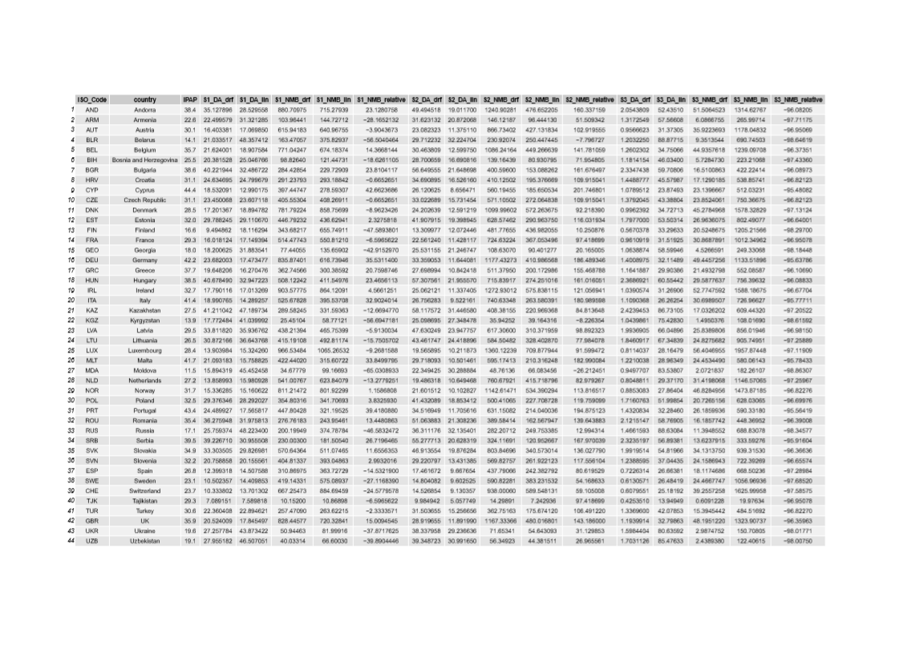

Baseline distributions of physical activity were derived for all countries included in the Health Economic Assessment Tool (n=49). For each scenario, we then estimated the number of deaths transformed the baseline distribution of every country, estimating the number of deaths averted

In order to make this comparison we take four steps:

1. We follow the method described in Hafner et al. (2019) to estimate the baseline distribution of physical activity in each of the 49 HEAT countries.
2. We create a new distribution of population physical activity for each country based on each of three scenarios outlined below in turn.
3. We estimate the change in mortality rates, and therefore deaths averted, given the new distribution of physical activity in each country using both the dose response relationship and the linear relationship methods.
4. We compare the number of deaths averted per 100,000 people using each method.

Since there is variation in the baseline distribution of physical activity, and mortality rates, in each country, we display the results for all countries together to observe the effects of these variables. It is also possible to estimate the relative effect of changing the method used to estimate the benefits of increased physical activity for different types of ‘what-if’ scenarios. We compare the effects of the following three scenarios:

The analysis described below uses data from the following sources. The data is available open source at the author’s GitHub account.

Step 1

We follow the method described in Hafner et al. (2019) to estimate a baseline distribution of physical activity in each of the 49 HEAT countries. This method first creates a generic distribution of physical activity for a country with good data. In this instance I use the distribution estimated for England using Health Survey for England 2015 data generated by the IPAQ survey. This looks something like this:

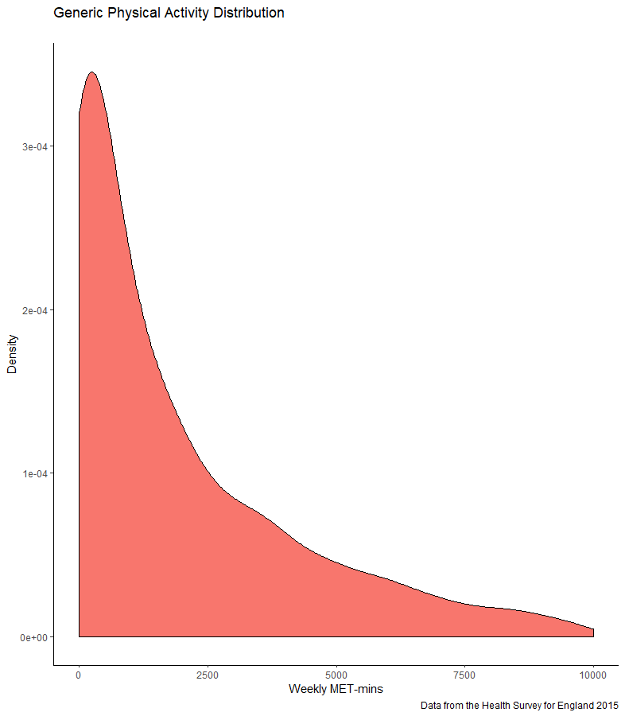 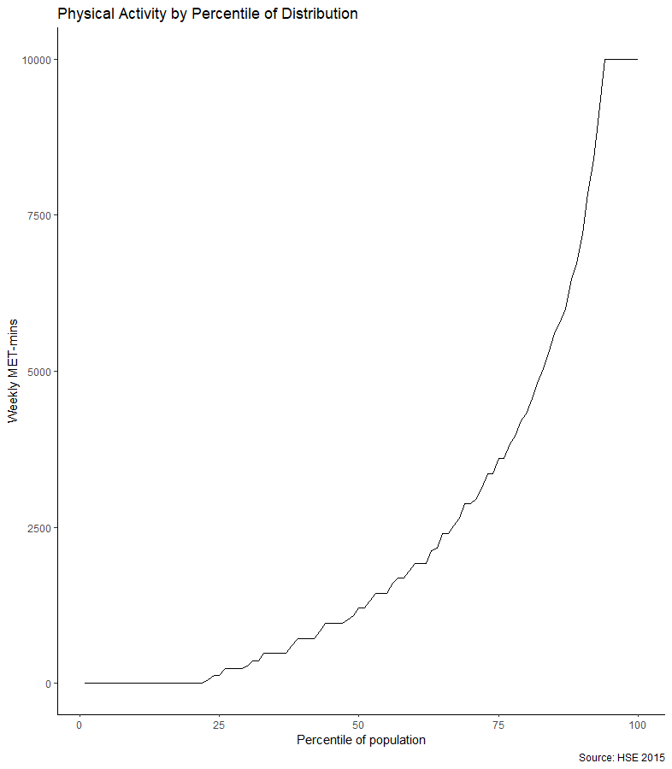

Then, using data provided by Guthold et al. (2018) on the prevalence of inactivity for XXX countries (below), we utilize an equation developed by Hafner et al. (2019) to estimate the weekly MET-mins, p, for each country c, at each percentile, n, from 1 to 100 based on the prevalence of inactivity, , in the country, c, compared to the prevalence of inactivity in the generic distribution (). The values for each percentile then form the estimated physical activity distribution for each country.

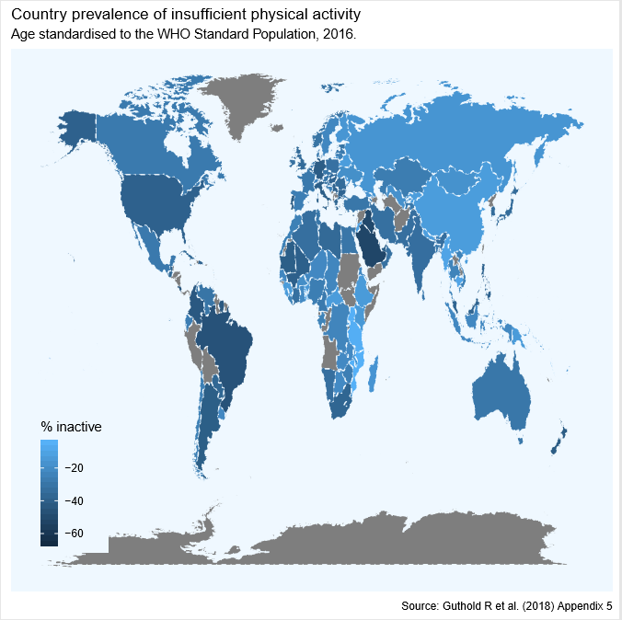

Step 2

For each of the three scenarios, and for each country, we transformed the physical activity distribution, creating a new country specific physical activity distribution. For example, in Scenario 1 the distribution was shifted to the right by 210 MET-mins (Walking at 3 METs for 10minutes on 7 days of the week).

## Step 3

We then, for each country in each scenario, use the two different methods to estimate the change in mortality associated with the change in the physical activity distribution. Since the linear method does not rely on the baseline distribution the calculation is simple (210METs reduces risk by x amount). For the non-linear dose-response function this is calculated by estimating the net change in relative risk for the population (the difference between the two lines below) and multiplying this by the population mortality rate.

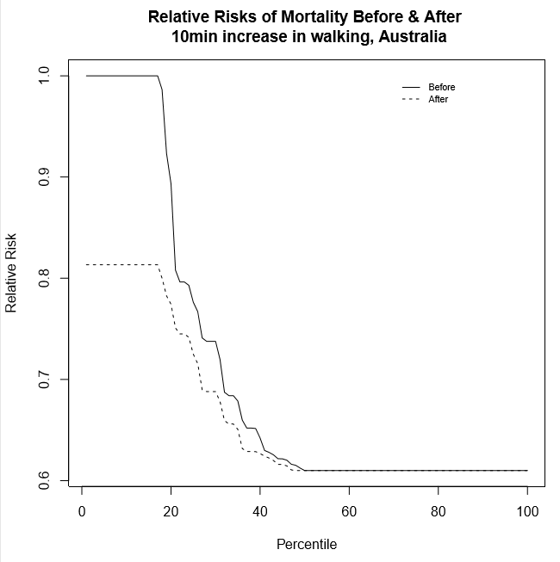

## Step 4

Next, in both the linear effect method and non-linear dose response method we multiply the change in the population mortality rate by 100,000 to estimate the deaths averted per 100,000. The two figures are then compared to contrast the results, for each of the three scenarios, in each of the 49 HEAT countries. Finally, since the HEAT model values deaths averted using the Value of a Statistical Life (VSL) approach, we apply the country specific VSL estimates to the deaths averted, to estimate for each country, the net monetary benefit of each scenario using a) the linear method, the non-linear method.

The distributions derived using these methods differ as shown below for the first 10 countries alphabetically in the sample of all countries worldwide. American Samoa, a very inactive nation where 53% of individuals are inactive, has the lowest levels of physical activity while Armenia, a country where only 22% of individuals are inactive, has the highest levels of physical activity. For ease of displaying data in all cases physical activity is capped at 10,000METs, a level far exceeding that where the benefits of additional physical activity are negligible.

